CSA0734-COMPUTER NETWORKS FOR SERVER MANAGEMENT

NAME: SAKTHIVEL V

REG. NO.: 192211689

EXPERIMENT 33

Applications using TCP File transfer in Java

Aim:

  To implement applications using TCP File transfer in Java.

Tools Required:

   1.JAVA software.

Procedure:

   STEP 1: Create a server socket using “socket()” function and bind it to the port.

**STEP** 2: Create a client socket using “socket()” function.

**STEP** 3: connect the client socket to the server using the “connect()” function.

**STEP** 4: accept the client connection using the “accept()” function.

**STEP** 5: Send the information over TCP connection using “send()” function on server’s side.

**STEP** 6: Receive the information from the server using “recv()” function on client’s side.

**STEP** 7: Continue receiving & writing data until the entire information is received.

**STEP** 8: Close the server and client socket using “close()” function.

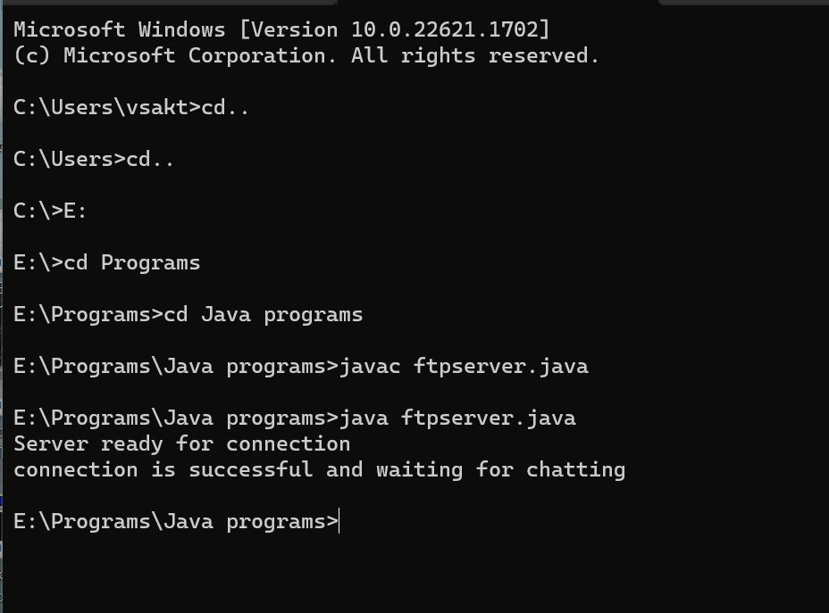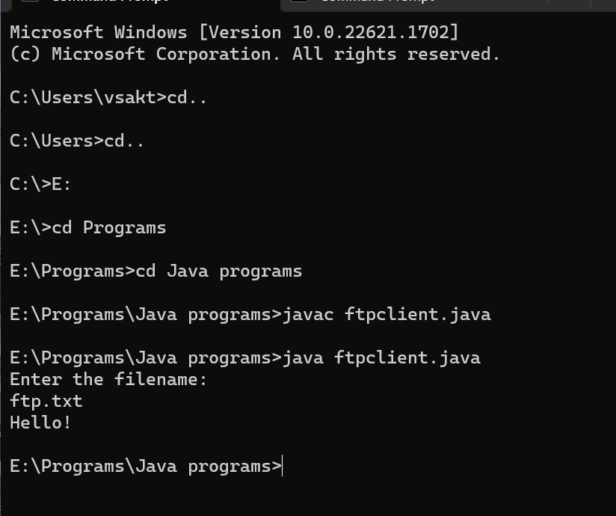

Result:

The applications using TCP File transfer has been executed Successfully.